**Day 4 – Local Area Network (LAN)**

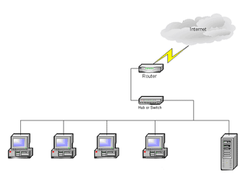

1. Modify the diagram above to show some additional devices connected to the LAN in your house.
2. Label the diagram above to show how these devices are connected to the LAN Hub in your house.
3. Label the diagram above to show how LAN in your house is connected to the Internet.
4. Create a new diagram for a LAN that could be found in a small business office.